Rebels Unite!: Bacon’s Rebellion vs. The Hunger Games
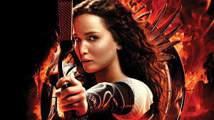
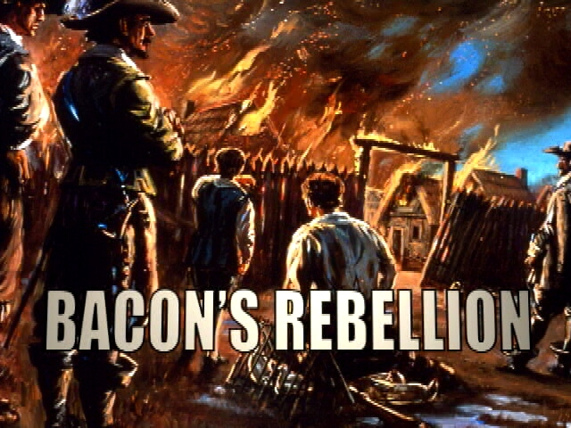

Rebellion- An act of violence or resistance to an established government or ruler

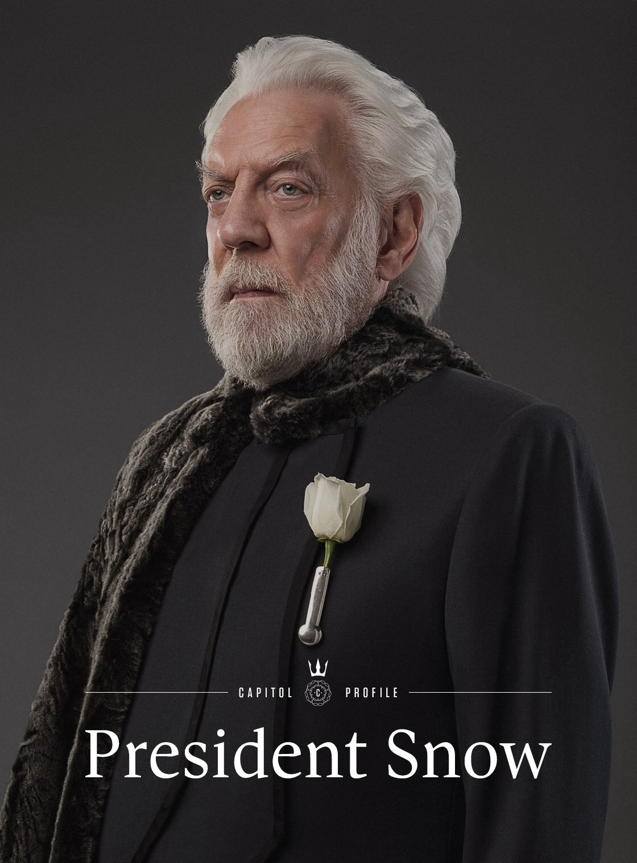
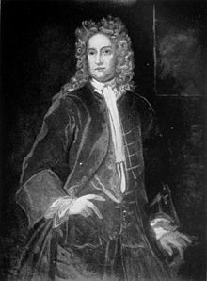
We have learned the basic story of Bacon’s Rebellion and who he as a person. Now, you are going to compare and contrast his rebellion to Katniss Everdeen’s from the Hunger Games. Using research and outside knowledge, you and your group will create a visual and detailed poster/presentation analyzing the similarities and differences between these two rebellions and their major characters.

Your goal is to: 1. Research your subjects of study (see below)
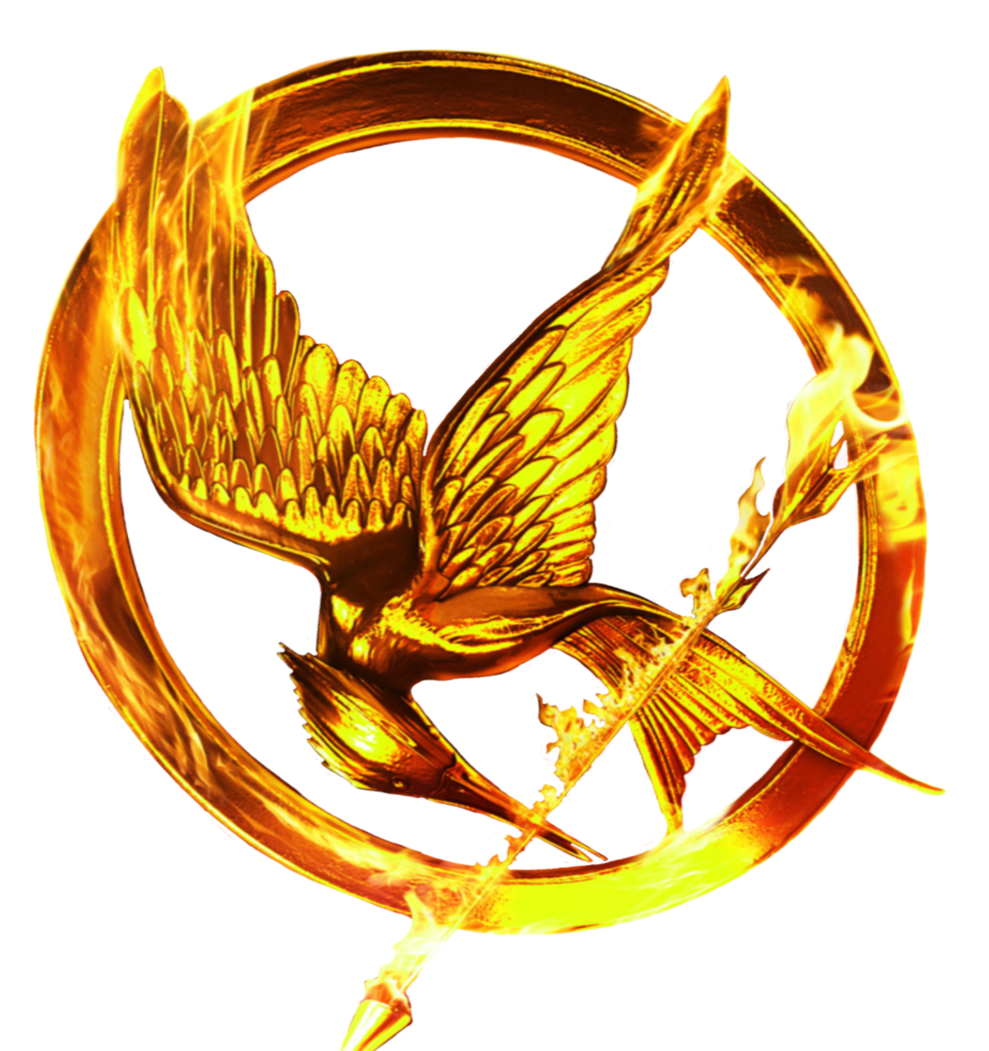
2. Determine how you are going to incorporate the questions below into your final product.

3. Determine how you will be presenting the final product (remember to make it creative and engaging!)

4. Equally distribute the work amongst the groups
5. Begin creating the finished product!
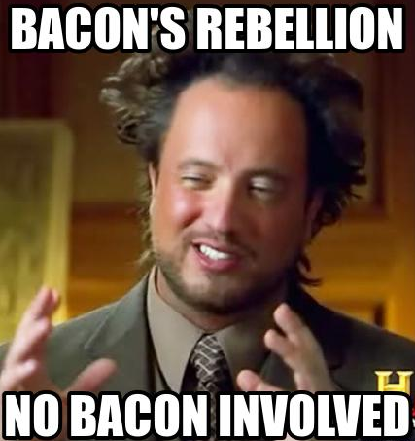

Groups who research…

Nathaniel Bacon and Katniss Everdeen
Be sure to discuss: 1. Each character’s personality/leadership qualities
2. Their actions in their conflicts
3. What happened to this character at the end of the conflict?
4. Overall, are these two people more similar or different to one another? Explain why!

Governor Berkeley and President Snow
Be sure to discuss: 1. Each characters personality/leadership qualities
2. Their actions in their conflict
3. What happened to this character at the end of the conflict?
4. Overall, are these two people more similar or different to one another? Explain why!

Bacon’s Rebellion and the Rebellion from the Hunger Games:
Be sure to discuss: 1. Why did each rebellion happen?
2. How did each rebellion deal with their problems?
3. What type of people fought in each rebellion?
4. What was the result of each rebellion?
5. Overall, are these two events more similar or different to one another? Explain why!

BACON’S REBELLION RUBRIC
Category | Point Value
Historical Accuracy  - Facts about your subject  - Explanation of background information about character or event assigned (10 points)  - Compare and contrast the characters or events you were assigned (20 points: 15-20 points = compared and contrasted in great detail and explained thoroughly (Mr. Lefer would be proud!), 10-14 points = somewhat compared and contrasted with errors in logic and research present, 0-10 points = minimal comparing and contrasting done with several errors) | 30
Requirements  - Completed in proper format with work cited (5 points: 4-5 points = made in a way that is visual and clear with work cited, 2-3 points = somewhat clear and eye-catching with questionable work cited, 0-1 point = not completed in the correct format without work cited)  - Includes answers to all questions asked in directions (15 points: 8-10 points = includes all questions answered accurately, 4-7 points = includes some questions answered which may not be correct, 0-3 points = includes few to no questions answered accurately)  - Remains on topic and focused while including clear logic and reasoning (10 points: 8-10 points = project remains focused throughout and has clear reasoning- Mr. Lefer is impressed, 4-7 points = project loses focus at times and has some logical errors – Mr. Lefer is a sort of ‘gets it’, 0-3 points = project little focus and little logic- Mr. Lefer is totally lost) | 30
Spelling and Grammar  - 10-15 points: spelling and grammar is at or above grade level, strong vocabulary is used  - 5-9 points: some spelling and grammatical errors exist, few strong vocabulary words are used  - 0-4 points: many spelling and grammatical errors exist, no strong vocabulary words are used | 15
Creativity and Effort  - 20-25 points: Strong effort is shown (it is clear that students spent a great deal of time on this assignment, project is detailed, highly creative and neat)  - 15 – 19 points: Some effort is shown (students seem to have rushed through parts of assignment, project is somewhat detailed and creative)  - 0-14 points: Little to no effort is shown (students seem to have spent little time and/or effort on this assignment, not creative or neat) | 25

